PROTOCOL 750303
SHOW GENERIC IMAGE OF E-PRODUCTS | 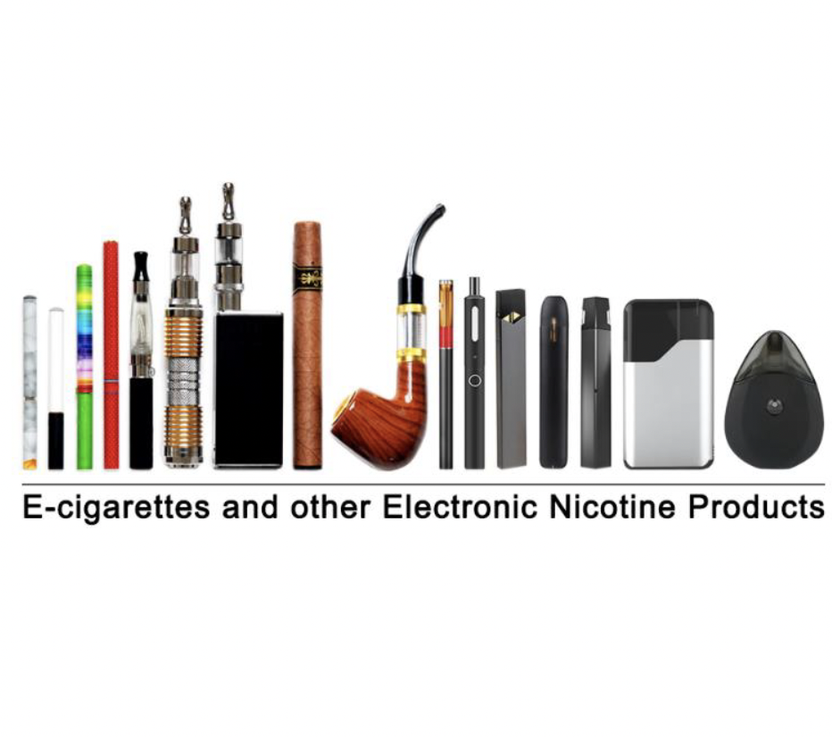
SHOW GENERIC IMAGE OF TRADITIONAL CIGARS | 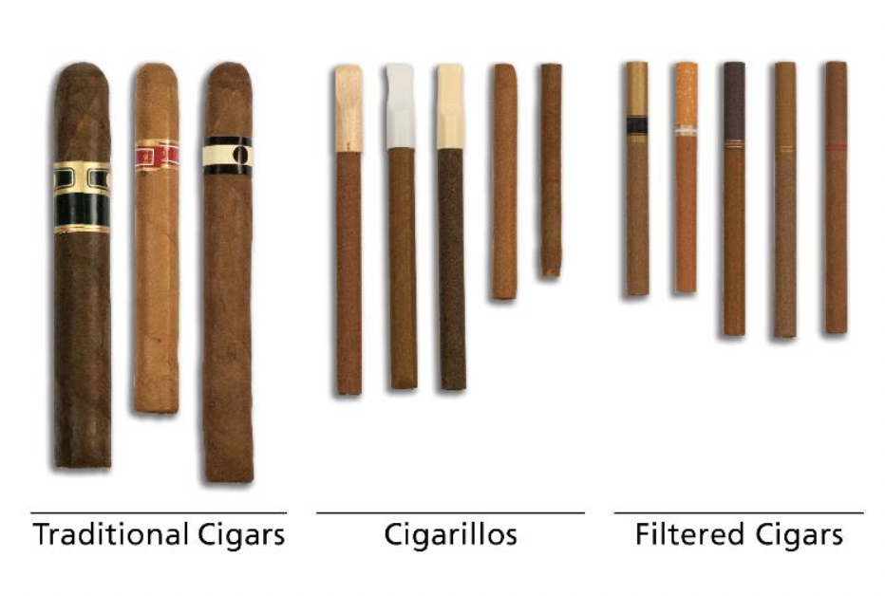
SHOW GENERIC IMAGE OF CIGARILLOS AND FILTERED CIGARS
SHOW GENERIC IMAGE OF PIPE | 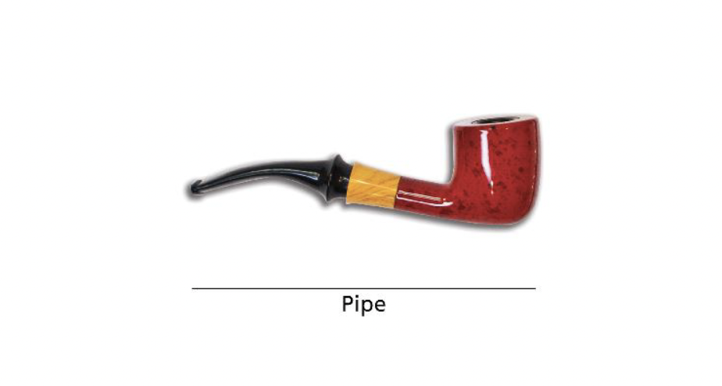
SHOW GENERIC IMAGE OF HOOKAH | 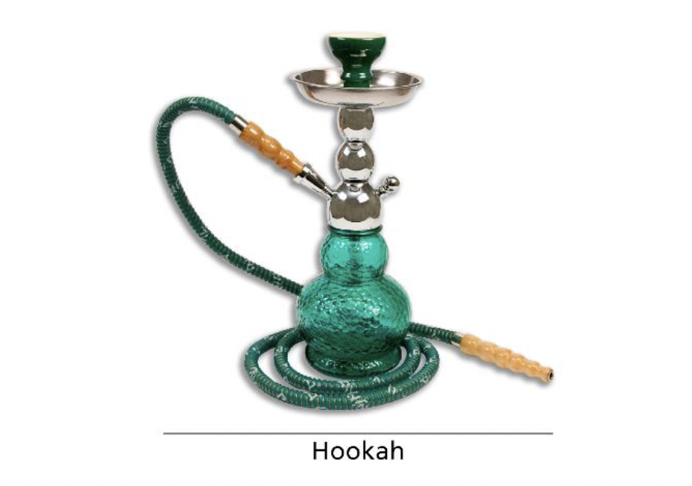
SHOW GENERIC IMAGE OF SMOKELESS PRODUCTS, EXCLUDING SNUS | 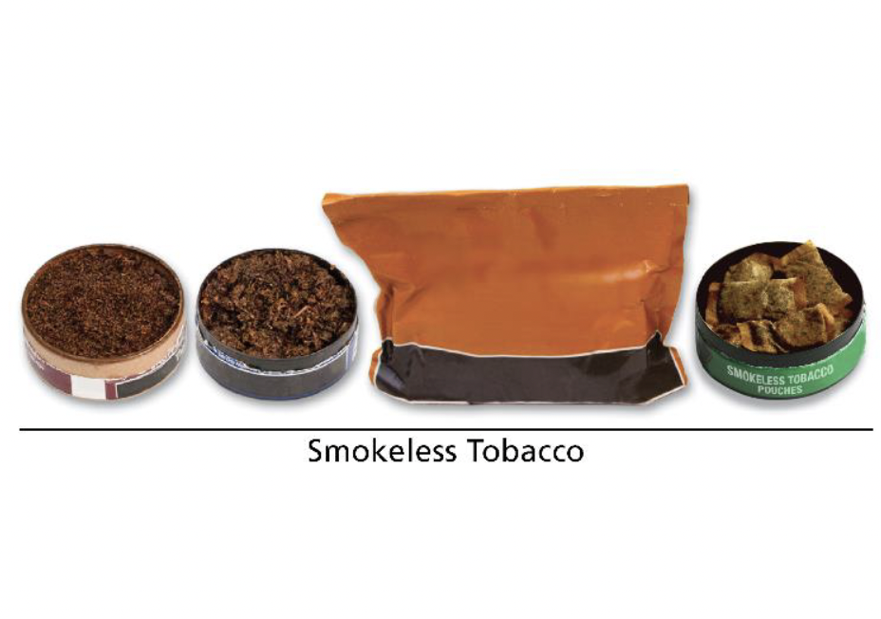
SHOW GENERIC IMAGE OF SNUS – BOTH LOOSE AND POUCHES | 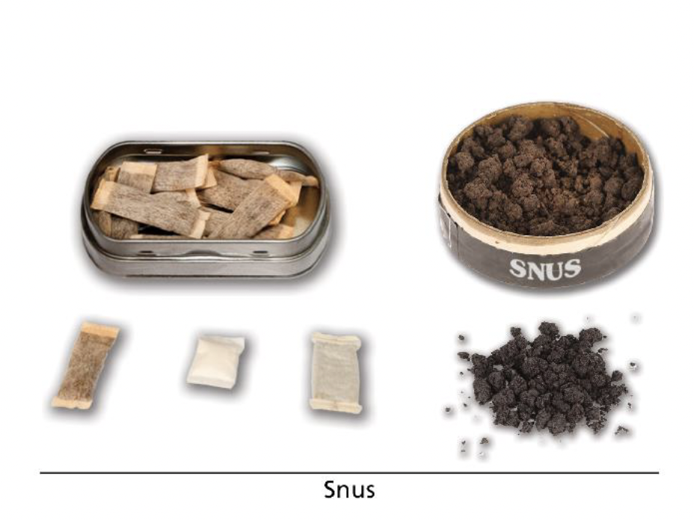
SHOW GENERIC IMAGE OF IQOS] | 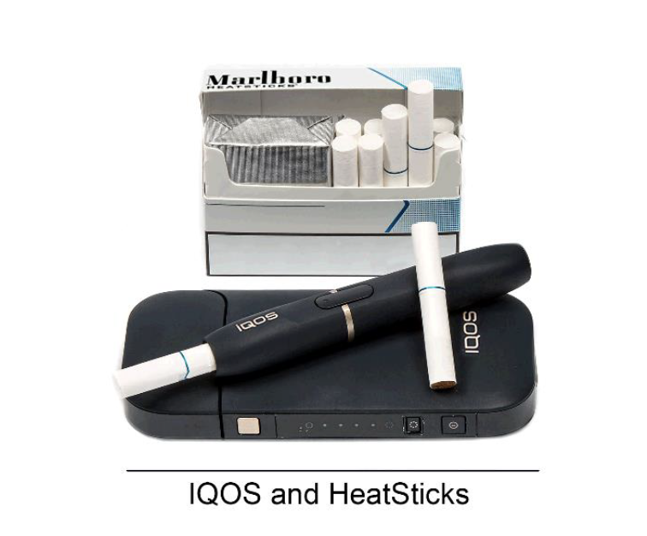
SHOW GENERIC IMAGE OF NICOTINE POUCHES | 