
Data Collection Worksheet
Please Note: The Data Collection Worksheet (DCW) is a tool to aid integration of a PhenX protocol into a study. The PhenX DCW is not designed to be a data collection instrument. Investigators will need to decide the best way to collect data for the PhenX protocol in their study. Variables captured in the DCW, along with variable names and unique PhenX variable identifiers, are included in the PhenX Data Dictionary (DD) files. Electronic Cigarettes (E-Cigarettes)
Electronic cigarettes, often called e-cigarettes look like regular cigarettes, but are battery-powered and produce vapor instead of smoke. There are many types of e-cigarettes. Some common brands include NJOY®, Blu™, and Smoking Everywhere.
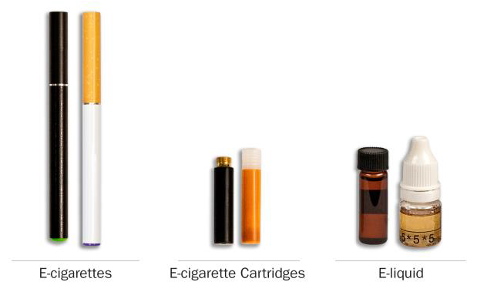
Cigars
Traditional cigars, cigarillos, and filtered cigars go by lots of different names, so please use these descriptions and photos to understand what they are.
Traditional cigars contain tightly rolled tobacco that is wrapped in a tobacco leaf. Some common brands of cigars include Macanudo®, Romeo y Julieta®, and Arturo Fuente®, but there are many others.
Cigarillos and filtered cigars are smaller than traditional cigars. They are usually brown. Some are the same size as cigarettes, and some come with plastic or wood tips. Some common brands are Black & Mild®, Swisher Sweets®, Dutch Masters®, Phillies Blunts®, Prime Time®, and Winchester®.
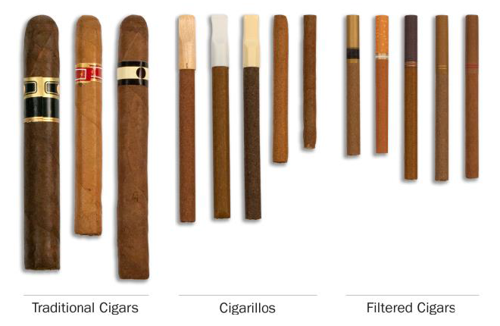
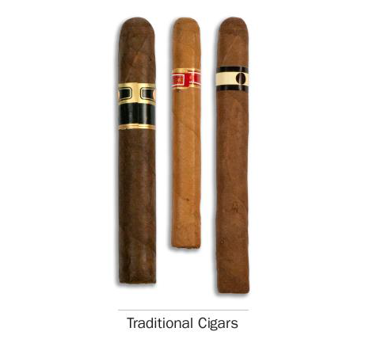
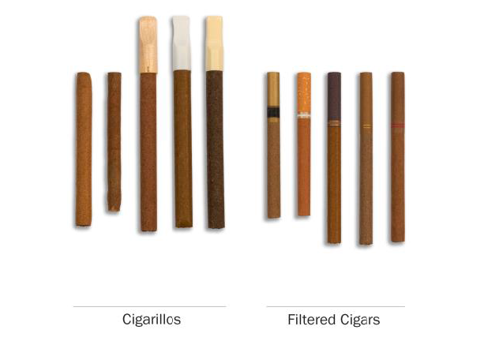
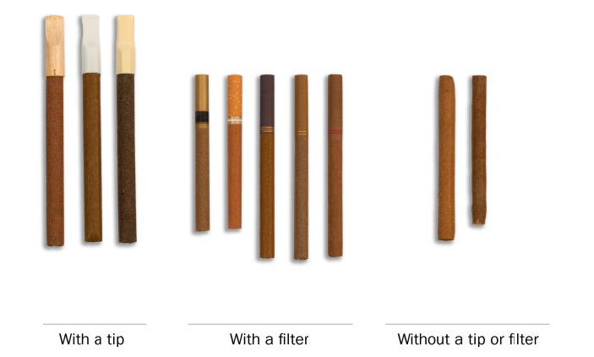
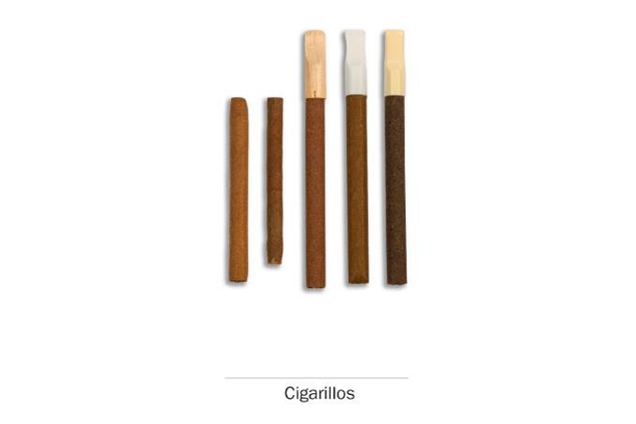
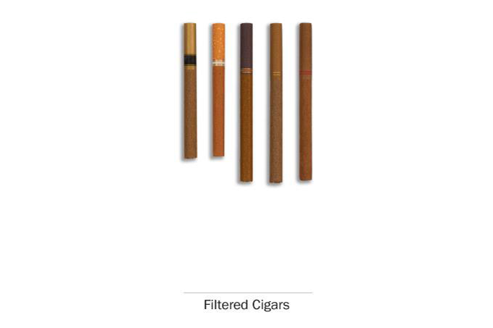
Pipe Tobacco
There are many different types of regular pipes. They all have a bowl that holds the tobacco and a stem.
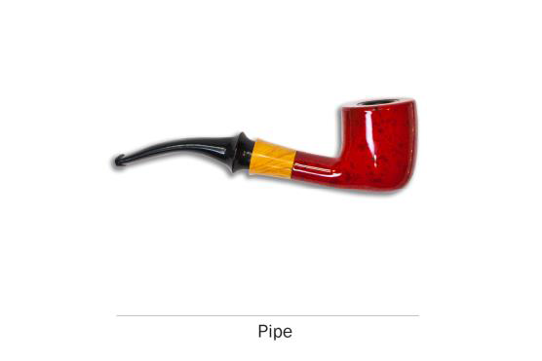
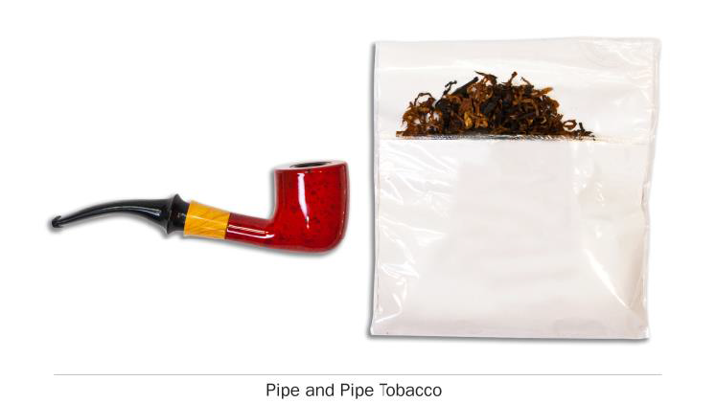
Hookah and Shisha
A hookah is a type of water pipe. It is sometimes also called a "narghile" pipe. There are many types of hookahs. People often smoke tobacco in hookahs in groups at cafes or in hookah bars.
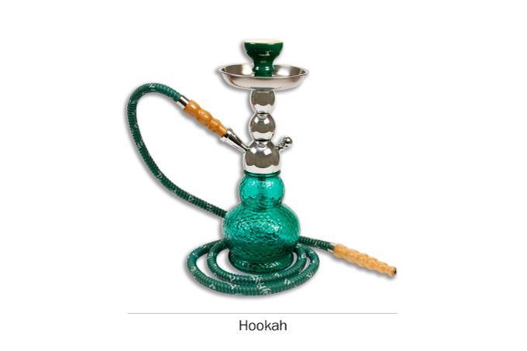
Smokeless Tobacco
Smokeless tobacco can be put in your mouth. Frequently you chew, suck or spit while using smokeless tobacco, although there is no need to do so for some types. Snus, for instance, is a type of smokeless tobacco that comes in a small pouch that you put inside your lip.
There are many kinds of smokeless tobacco, such as snus pouches, loose snus, moist snuff, dip, spit, and chewing tobacco. Common brands include Redman®, Levi Garrett®, Beechnut®, Skoal®, Grizzly®, Nordic Ice®, and Copenhagen®.
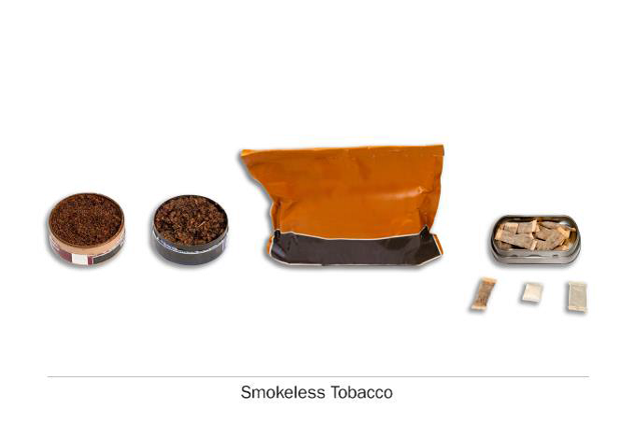
Dissolvable Tobacco
Dissolvable tobacco products are not smoked-they are made of finely ground flavored tobacco that dissolves in your mouth.
Dissolvable tobacco products come in a variety of shapes, including small round pellets, thin sticks and flat strips. Some common brands are Ariva®, Stonewall™, and Camel Orbs, Sticks, or Strips.
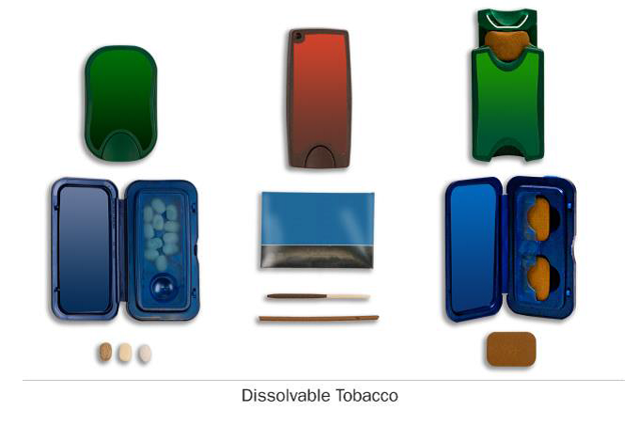
1. Does anyone who lives with you now do any of the following? Choose all that apply.
1 [ ] Smoke cigarettes
2 [ ] Use smokeless tobacco, such as chewing tobacco, snuff, dip, or snus
3 [ ] Smoke cigars, cigarillos, or filtered cigars
4 [ ] Use any other form of tobacco
5 [ ] No one who lives with me now uses any form of tobacco
-8 [ ] Don’t know
-7 [ ] Refused
2. Of the five closest friends or acquaintances that you spend time with on a regular basis, how many of them are smokers?
[ ] INSERT 0 to 5
3. Thinking about the people who are important to you, how would you describe their opinion on using tobacco?
1 [ ] Very positive
2 [ ] Positive
3 [ ] Neither positive nor negative
4 [ ] Negative
5 [ ] Very negative
4. How would you describe most people’s opinion of using tobacco?
1 [ ] Very positive
2 [ ] Positive
3 [ ] Neither positive nor negative
4 [ ] Negative
5 [ ] Very negative
Protocol source: https://www.phenxtoolkit.org/protocols/view/750301

