
Data Collection Worksheet
Please Note: The Data Collection Worksheet (DCW) is a tool to aid integration of a PhenX protocol into a study. The PhenX DCW is not designed to be a data collection instrument. Investigators will need to decide the best way to collect data for the PhenX protocol in their study. Variables captured in the DCW, along with variable names and unique PhenX variable identifiers, are included in the PhenX Data Dictionary (DD) files. Cigarettes
1. Have you ever smoked a cigarette, even one or two puffs?
1 [ ] Yes
2 [ ] No [GO TO Q6]
-8 [ ] DON’T KNOW [GO TO Q6]
-7 [ ] REFUSED [GO TO Q6]
ASK: All respondents
2. Do you now smoke cigarettes…
1 [ ] Every day
2 [ ] Some days
3 [ ] Not at all [GO TO Q3]
-8 [ ] DON’T KNOW [GO TO Q3]
-7 [ ] REFUSED [GO TO Q3]
ASK: Respondents who have ever smoked a cigarette (Q1 = 1)
3. In the past 30 days, have you smoked a cigarette, even one or two puffs?
1 [ ] Yes
2 [ ] No
-8 [ ] REFUSED
-7 [ ] DON’T KNOW
ASK: Respondents who do not currently smoke every day or some days (Q2 = 3)
4. How many cigarettes have you smoked in your entire life? A pack usually has 20 cigarettes in it.
1 [ ] 1 or more puffs but never a whole cigarette
2 [ ] 1 to 10 cigarettes (about ½ pack total)
3 [ ] 11 to 20 cigarettes (about ½ pack to 1 pack)
4 [ ] 21 to 50 cigarettes (more than 1 pack but less than 3 packs)
5 [ ] 51 to 99 (more than 2 ½ packs but less than 5 packs)
6 [ ] 100 or more cigarettes (5 packs or more)
-8 [ ] DON’T KNOW
-7 [ ] REFUSED
ASK: Respondents who have ever smoked a cigarette (Q1 =1)
5. About how long has it been since you completely quit smoking cigarettes?
1 [ ] I___I___I DAYS
2 [ ] I___I___I MONTHS
3 [ ] I___I___I YEARS
-8 [ ] DON’T KNOW
-7 [ ] REFUSED
ASK: Former users (IF Q1 = 1 AND Q4 = 5 AND Q2 = 3) and Experimental Former users (IF Q1 = 1 AND Q4 = 1, 2, 3, 4 AND Q2 = 3). Else go to next section (Q6).
Electronic Cigarettes (E-Cigarettes)
The next questions are about electronic cigarettes, often called e-cigarettes. E-cigarettes look like regular cigarettes, but are battery-powered and produce vapor instead of smoke. There are many types of e-cigarettes. Some common brands include NJOY®, Blu™, and Smoking Everywhere.
SHOW GENERIC IMAGE OF E-CIGARETTES
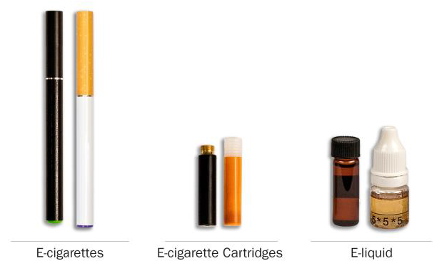
6. Have you ever seen or heard of an electronic cigarette or e-cigarette before this study?
1 [ ] Yes
2 [ ] No [GO TO Q13]
-8 [ ] DON’T KNOW [GO TO Q13]
-7 [ ] REFUSED [GO TO Q13]
ASK: All respondents
SHOW GENERIC IMAGE OF E-CIGARETTES
7. Have you ever used an e-cigarette, such as NJOY®, Blu™, or Smoking Everywhere, even one or two times?
1 [ ] Yes
2 [ ] No [GO TO Q13]
-8 [ ] DON’T KNOW [GO TO Q13]
-7 [ ] REFUSED [GO TO Q13]
ASK: Respondents who have seen or heard of e-cigarettes (Q6 = 1)
SHOW GENERIC IMAGE OF E-CIGARETTES
8. Do you now use e-cigarettes…
1 [ ] Every day
2 [ ] Some days
3 [ ] Not at all
-8 [ ] DON’T KNOW
-7 [ ] REFUSED
ASK: Respondents who have used an e-cigarette (Q7 = 1)
9. In the past 30 days, have you used an e-cigarette, even one or two times?
1 [ ] Yes
2 [ ] No
-8 [ ] DON’T KNOW
-7 [ ] REFUSED
ASK: Respondents who have used an e-cigarette (Q7 = 1) AND do not currently use e-cigarettes every day or some days (Q8 = 3).
10. How many disposable e-cigarettes or e-cigarette cartridges have you used in your entire life?
1 [ ] 1 or more puffs but never a whole one
2 [ ] 1 to 10
3 [ ] 11 to 20
4 [ ] 21 to 50
5 [ ] 51 to 99
6 [ ] 100 or more
-8 [ ] DON’T KNOW
-7 [ ] REFUSED
ASK: Respondents who have used an e-cigarette (Q7 = 1).
11. About how long has it been since you last took a puff from an e-cigarette? (If it was earlier today, enter 1 day).
1 [ ] I___I___I DAYS
2 [ ] I___I___I MONTHS
3 [ ] I___I___I YEARS
-8 [ ] DON’T KNOW
-7 [ ] REFUSED
ASK: Respondents who have used e-cigarettes (Q7 = 1) AND do not use every day (Q8 <> 1)
GO TO: If Q8 = 3, go to Q12. Else go to Q13.
12. Have you completely quit using e-cigarettes?
1 [ ] Yes
2 [ ] No
-8 [ ] DON’T KNOW
-7 [ ] REFUSED
ASK: Respondents who have used e-cigarettes (Q7 = 1) AND currently use not at all (Q8 = 3).
Cigars
The next questions are about traditional cigars, cigarillos, and filtered cigars. These products go by lots of different names, so please use these descriptions and photos to understand what they are.
Traditional cigars contain tightly rolled tobacco that is wrapped in a tobacco leaf. Some common brands of cigars include Macanudo®, Romeo y Julieta®, and Arturo Fuente®, but there are many others.
Cigarillos and filtered cigars are smaller than traditional cigars. They are usually brown. Some are the same size as cigarettes, and some come with plastic or wood tips. Some common brands are Black & Mild®, Swisher Sweets®, Dutch Masters®, Phillies Blunts®, Prime Time®, and Winchester®.
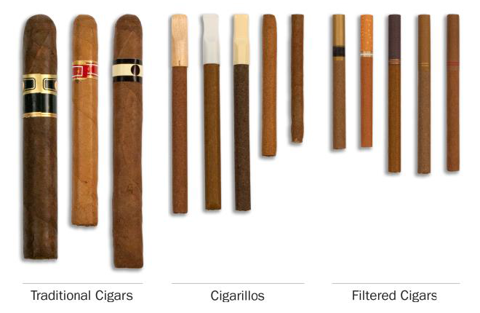
13. Have you ever seen or heard of a cigar, cigarillo, or filtered cigar before this study?
1 [ ] Yes
2 [ ] No [GO TO Q26]
-8 [ ] DON’T KNOW [GO TO Q26]
-7 [ ] REFUSED [GO TO Q26]
ASK: All respondents
SHOW GENERIC IMAGE OF TRADITIONAL CIGARS, CIGARILLOS, AND FILTERED CIGARS
14. Which type of cigar have you heard of before this study?
1 [ ] Traditional cigars like Macanudo®, Romeo y Julieta®, Arturo Fuente®, or others [GO TO Q15]
2 [ ] Cigarillos or filtered cigars like Black & Mild®, Swisher Sweets®, Dutch Masters®, Phillies Blunts®, Prime Time®, Winchester®, or others [GO TO Q15]
-8 [ ] DON’T KNOW [GO TO Q26]
-7 [ ] REFUSED [GO TO Q26]
ASK: Respondents who have seen or heard of a cigar, cigarillo, or filtered cigar (Q13 = 1)
GO TO: If R has not heard of either type of cigar (Q14 NOT IN (1, 2)), go to Q26.
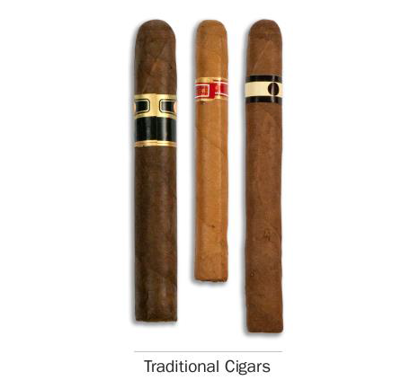
15. Have you ever smoked a traditional cigar, even one or two puffs?
1 [ ] Yes
2 [ ] No
-8 [ ] DON’T KNOW
-7 [ ] REFUSED
ASK: Respondents who have heard of a traditional cigar (Q14 IN TRADITIONAL CIGAR)
SHOW GENERIC IMAGE OF TRADITIONAL CIGARS
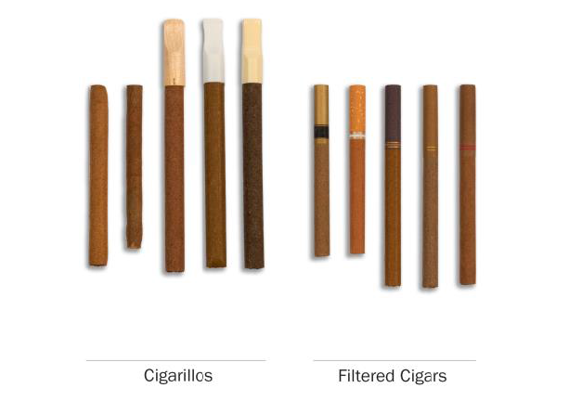
16. Have you ever smoked a cigarillo or filtered cigar, even one or two puffs?
1 [ ] Yes
2 [ ] No
-8 [ ] DON’T KNOW
-7 [ ] REFUSED
ASK: Respondents who have heard of a cigarillo/FC (Q14 IN "CIGARILLO OR FILTERED CIGAR")
SHOW GENERIC IMAGE OF CIGARILLOS AND FILTERED CIGARS
17. Sometimes people take tobacco out of a cigar, cigarillo or filtered cigar and replace it with marijuana. This is sometimes called a "blunt." Have you ever smoked part or all of a cigar, cigarillo or filtered cigar with marijuana in it?
1 [ ] Yes
2 [ ] No [GO TO Q20]
-8 [ ] DON’T KNOW [GO TO Q20]
-7 [ ] REFUSED [GO TO Q20]
ASK: Respondents who have seen or heard of a cigar, cigarillo or filtered cigar (Q13 = 1 AND Q14 IN (1 or 2) AND Q16 NE -8 or -7).
18. In the past 12 months, have you smoked part or all of a cigar, cigarillo or filtered cigar with marijuana in it?
1 [ ] Yes
2 [ ] No [GO TO Q20]
-8 [ ] DON’T KNOW [GO TO Q20]
-7 [ ] REFUSED [GO TO Q20]
ASK: Respondents who have smoked cigars with marijuana (Q17 = 1).
19. In the past 12 months, when you smoked a cigar, cigarillo or filtered cigar, how often has tobacco been replaced with any marijuana?
1 [ ] Every time
2 [ ] Most of the time
3 [ ] Sometimes
4 [ ] Rarely
5 [ ] Never
-8 [ ] DON’T KNOW
-7 [ ] REFUSED
ASK: Respondents who have smoked cigars with marijuana in the past 12 months (Q18 = 1).
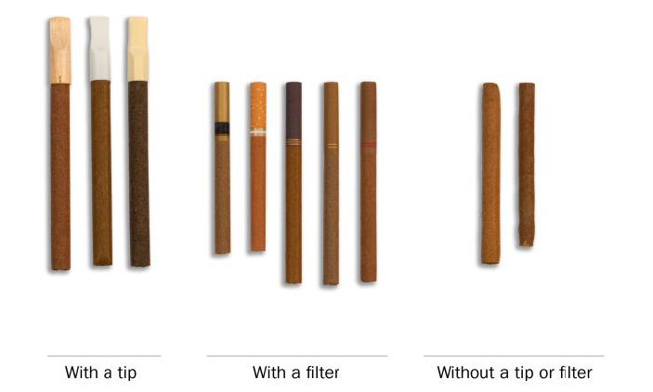
20. Which of the following kinds of cigarillos or filtered cigars have you smoked [as blunts]? Choose all that apply. The kind…
1 [ ] With a plastic or wooden tip
2 [ ] With a filter (like a cigarette filter)
3 [ ] Without a tip or filter
-8 [ ] DON’T KNOW
-7 [ ] REFUSED
ASK: Respondents who have smoked a cigarillo/FC (Q16 = 1) OR are blunt-only cigar smokers
(Q16 = 2 AND Q18 = 1).
PROGRAM: Display "as blunts" if Q16 = 2 AND Q18 = 1.
SHOW GENERIC IMAGE OF CIGARILLOS WITH TIPS, FILTERED CIGARS, AND CIGARILLOS WITHOUT TIPS
21. Do you now smoke [ [CIGARFILL]s/cigarillos as blunts/filtered cigars as blunts ]…
1 [ ] Every day
2 [ ] Some days
3 [ ] Not at all [GO TO Q22]
-8 [ ] DON’T KNOW [GO TO Q22]
-7 [ ] REFUSED [GO TO Q22]
ASK: Respondents who have smoked at least one type of cigar (regular cigar (Q15 = 1) and/or cigarillo
(Q20 = 1 OR 3) and/or FC (Q20 = 2)) OR are blunt-only cigar smokers (Q16 = 2 AND Q18 = 1).
PROGRAM: If Q16 = 2 AND Q18 = 1 AND Q20 = 1 OR 3, display "cigarillos as blunts." If Q16 = 2
AND Q18 = 1 AND Q20 = 2, display ‘filtered cigars as blunts’. Else, display [CIGARFILL]s as specified.
22. In the past 30 days, have you smoked a [ [CIGARFILL]/ cigarillos as a blunt/ filtered cigar as a blunt ], even one or two puffs?
1 [ ] Yes
2 [ ] No
-8 [ ] DON’T KNOW
-7 [ ] REFUSED
ASK: Respondents who have smoked at least one type of cigar (regular cigar (Q15=1) and/or cigarillo
(Q20 = 1 OR 3) and/or FC (Q20 = 2)) OR are blunt-only cigar smokers (Q16 = 2 AND Q18 = 1) and do not currently smoke every day or some days (Q21 = 3).
PROGRAM: If Q16 = 2 AND Q18 = 1 AND Q20 = 1 OR 3, display "cigarillo as a blunt." If Q16 = 2
AND Q18 = 1 AND Q20 = 2, display "filtered cigar as a blunt." Else, display [CIGARFILL] as specified.
23. How many [CIGARFILL]s have you smoked in your entire life?
1 [ ] 1 or more puffs but never a whole one
2 [ ] 1 to 10
3 [ ] 11 to 20
4 [ ] 21 to 50
5 [ ] 51 to 99
6 [ ] 100 or more
-8 [ ] DON’T KNOW
-7 [ ] REFUSED
ASK: Respondents who have smoked at least one type of cigar where traditional cigar (Q15 = 1) and/or cigarillo (Q20 = 1 OR 3) and/or LFC (Like a filtered cigar) (Q20 = 2).
24. About how long has it been since you last smoked [CIGARFILL]s? (If it was earlier today, enter 1 day)
1 [ ] I___I___I DAYS
2 [ ] I___I___I MONTHS
3 [ ] I___I___I YEARS
-8 [ ] DON’T KNOW
-7 [ ] REFUSED
ASK: Respondents who have smoked [CIGARFILL]s and do not smoke every day (Q21 <> 1)
GO TO: If Q21 = 3, go to Q25. Else go to next section.
25. Have you completely quit smoking [CIGARFILL]s?
1 [ ] Yes
2 [ ] No
-8 [ ] DON’T KNOW
-7 [ ] REFUSED
ASK: Respondents who have smoked [CIGARFILL]s and currently smoke not at all (Q21 = 3).
Pipe Tobacco
The next questions are about smoking tobacco in pipes. We first ask about smoking tobacco in a regular pipe. There are many different types of regular pipes. They all have a bowl that holds the tobacco and a stem.
Regular Pipe
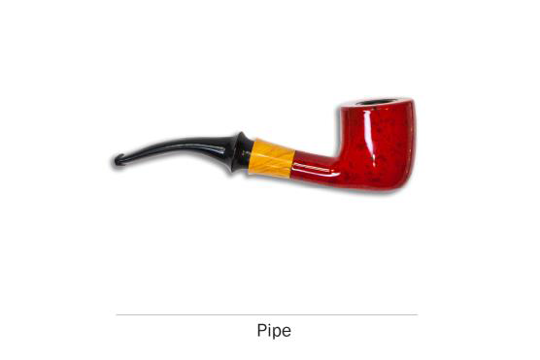
26. Have you ever seen or heard of a pipe before this study?
1 [ ] Yes
2 [ ] No [GO TO Q33]
-8 [ ] DON’T KNOW [GO TO Q33]
-7 [ ] REFUSED [GO TO Q33]
ASK: All respondents
DISPLAY GENERIC IMAGES OF PIPES
27. Have you ever smoked a pipe filled with tobacco, even one or two puffs?
1 [ ] Yes
2 [ ] No [GO TO Q33]
-8 [ ] DON’T KNOW [GO TO Q33]
-7 [ ] REFUSED [GO TO Q33]
ASK: Respondents who have seen or heard of pipes (Q26 = 1).
DISPLAY GENERIC IMAGES OF PIPES
28. Do you now smoke a pipe filled with tobacco…
1 [ ] Every day [GO TO Q30]
2 [ ] Some days [GO TO Q30]
3 [ ] Not at all [GO TO Q29]
-8 [ ] DON’T KNOW [GO TO Q29]
-7 [ ] REFUSED [GO TO Q29]
ASK: Respondents who have a smoked pipe filled with tobacco (Q27 = 1)
29. In the past 30 days, have you smoked a regular pipe filled with tobacco, even one or two puffs?
1 [ ] Yes
2 [ ] No
-8 [ ] DON’T KNOW
-7 [ ] REFUSED
ASK: Respondents who have smoked a pipe filled with tobacco (Q27 = 1) AND do not currently smoke pipes every day or Some Days (Q28 = 3).
[SHOW IMAGES OF PIPES AND PIPE TOBACCO - BOTH LOOSE AND IN TINS]
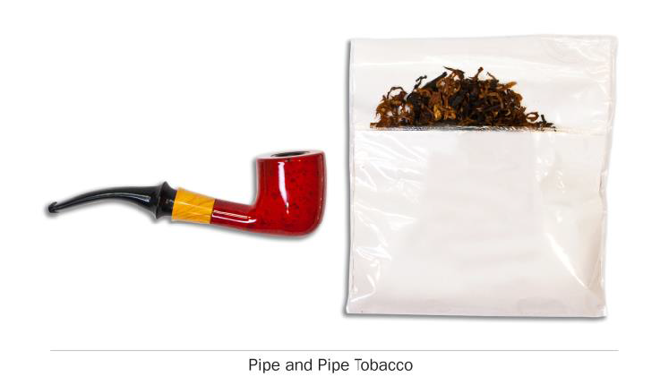
30. How many bowls filled with pipe tobacco have you smoked in your entire life?
1 [ ] 1 or more puffs but never a whole one
2 [ ] 1 to 10
3 [ ] 11 to 20
4 [ ] 21 to 50
5 [ ] 51 to 99
6 [ ] 100 or more
-8 [ ] DON’T KNOW
-7 [ ] REFUSED
ASK: Respondents who have smoked a pipe (Q27 = 1).
31. When did you last smoke a pipe filled with tobacco?
1 [ ] In the past hour
2 [ ] Sometime today
3 [ ] Yesterday
4 [ ] Day before yesterday
5 [ ] Three or more days ago
-8 [ ] DON’T KNOW
-7 [ ] REFUSED
ASK: Respondents who smoke a pipe everyday or some days (Q28 = 1, 2, -8, or -7)
32. About how long has it been since you last smoked a pipe filled with tobacco? (If it was earlier today, enter 1 day)
1 [ ] I___I___I DAYS
2 [ ] I___I___I MONTHS
3 [ ] I___I___I YEARS
-8 [ ] DON’T KNOW
-7 [ ] REFUSED
ASK: Respondents who have smoked a pipe (Q27 = 1) and do not smoke every day (Q28 <> 1)
PROGRAM: EXCLUDE Some day smokers (Q28 = 2) who previously reported they last smoked in the past hour, sometime today, yesterday, or the day before yesterday (Q31 = 1 or 2 or 3 or 4).
Hookah and Shisha
We next ask about smoking tobacco in a hookah, which is a type of water pipe. It is sometimes also called a "narghile" pipe. From now on, we will use "hookah" to refer to a water pipe or narghile pipe that is often used to smoke tobacco. There are many types of hookahs. People often smoke tobacco in hookahs in groups at cafes or in hookah bars.
[DISPLAY GENERIC IMAGE OF HOOKAH]
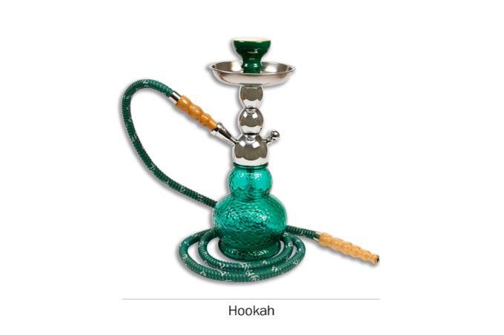
33. Have you ever seen or heard of a hookah before this study?
1 [ ] Yes
2 [ ] No [GO TO Q43]
-8 [ ] DON’T KNOW [GO TO Q43]
-7 [ ] REFUSED [GO TO Q43]
ASK: All respondents
[DISPLAY GENERIC IMAGE OF HOOKAH]
34. Have you ever smoked tobacco in a hookah, even one or two puffs?
1 [ ] Yes
2 [ ] No [GO TO Q43]
-8 [ ] DON’T KNOW [GO TO Q43]
-7 [ ] REFUSED [GO TO Q43]
ASK: Respondents who have seen or heard of a hookah (Q33 = 1)
[DISPLAY GENERIC IMAGE OF HOOKAH]
35. Do you now smoke hookah…
1 [ ] Every day
2 [ ] Some days
3 [ ] Not at all [GO TO Q43]
-8 [ ] DON’T KNOW [GO TO Q43]
-7 [ ] REFUSED [GO TO Q43]
ASK: Respondents who have smoked hookah (Q34 = 1)
36. How many times have you smoked hookah in your entire life? Count each sitting or session where you smoked tobacco in a hookah, whether alone or with others.
1 [ ] 1 to 10
2 [ ] 11 to 20
3 [ ] 21 to 50
4 [ ] 51 to 99
5 [ ] 100 or more
-8 [ ] DON’T KNOW
-7 [ ] REFUSED
ASK: Respondents who have ever smoked hookah (Q34 = 1).
37. When did you last smoke hookah?
1 [ ] In the past hour
2 [ ] Sometime today
3 [ ] Yesterday
4 [ ] Day before yesterday
5 [ ] Three or more days ago
-8 [ ] DON’T KNOW
-7 [ ] REFUSED
ASK: Respondents who smoke hookah everyday or some days (Q35 = 1, 2, -8, or -7).
38. About how long has it been since you last smoked hookah? (If it was earlier today, enter 1 day)
1 [ ] I___I___I DAYS [GO TO Q42]
2 [ ] I___I___I MONTHS [GO TO Q42]
3 [ ] I___I___I YEARS [GO TO Q42]
-8 [ ] DON’T KNOW
-7 [ ] REFUSED
ASK: Respondents who have ever smoked hookah (Q34 = 1) and do not smoke every day (Q35 <> 1)
PROGRAM: EXCLUDE Some day smokers (Q35 = 2) who previously reported they last smoked in the past hour, sometime today, yesterday, or the day before yesterday (Q37=1 or 2 or 3 or 4).
39. Have you smoked hookah at least once in the past 30 days?
1 Yes [GO TO Q42]
2 No
-8 DON’T KNOW
-7 REFUSED
ASK: Respondents who did not provide the amount of time that has passed since they had last smoked hookah (Q38 IN (DK,R))
40. Have you smoked hookah at least once in the past three months?
1 Yes [GO TO Q42]
2 No
-8 DON’T KNOW
-7 REFUSED
ASK: Respondents who did not provide the amount of time that has passed since they had last smoked hookah AND have not smoked hookah at least once in the past 30 days (Q38 IN (DK,R) AND Q39 IN (2, DK, R)).
41. Have you smoked hookah at least once in the past twelve months?
1 [ ] Yes
2 [ ] No
-8 [ ] DON’T KNOW
-7 [ ] REFUSED
ASK: Respondents who did not provide the amount of time that has passed since they had last smoked
hookah AND have not smoked hookah at least once in the past 3 months (Q38 IN (DK,R) AND Q39 IN (2, DK, R) AND Q40 IN (2, DK, R)).
If Q40 <> 1 OR Q38 > 90 DAYS or 3 MONTHS, go to Q42.
42. Have you completely quit smoking hookah?
1 [ ] Yes
2 [ ] No
-8 [ ] DON’T KNOW
-7 [ ] REFUSED
ASK: Respondents who have not smoked hookah in the last three months (Q40 <> 1 OR Q38 > 90 DAYS or 3 MONTHS)
Smokeless Tobacco
The next questions ask about smokeless tobacco which you put in your mouth. Frequently you chew, suck or spit while using smokeless tobacco, although there is no need to do so for some types. Snus, for instance, is a type of smokeless tobacco that comes in a small pouch that you put inside your lip.
There are many kinds of smokeless tobacco, such as snus pouches, loose snus, moist snuff, dip, spit, and chewing tobacco. Common brands include Redman®, Levi Garrett®, Beechnut®, Skoal®, Grizzly®, Nordic Ice®, and Copenhagen®.
[SHOW GENERIC IMAGES OF SMOKELESS TOBACCO]
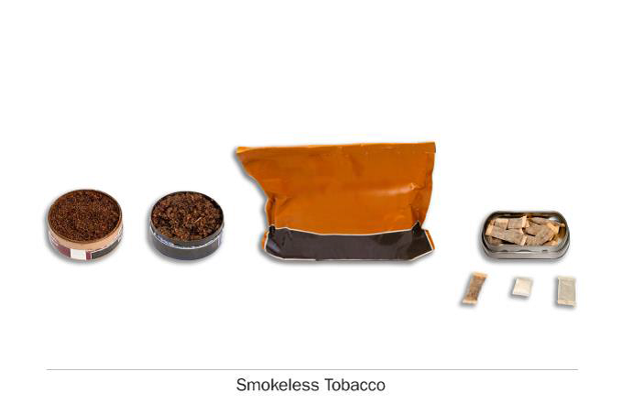
43. Have you ever seen or heard of smokeless tobacco, such as snus pouches, loose snus, moist snuff, dip, spit, or chewing tobacco, before this study?
1 [ ] Yes
2 [ ] No [GO TO Q51]
-8 [ ] DON’T KNOW [GO TO Q51]
-7 [ ] REFUSED [GO TO Q51]
ASK: All respondents
[SHOW GENERIC IMAGES OF SMOKELESS TOBACCO]
44. Have you ever used any of the following smokeless tobacco products, even one or two times? Choose all that apply.
1 [ ] Snus pouches
2 [ ] Loose snus, moist snuff, dip, spit, or chewing tobacco
3 [ ] I have never used a smokeless tobacco product [GO TO Q51]
-8 [ ] DON’T KNOW [GO TO Q51]
-7 [ ] REFUSED [GO TO Q51]
ASK: Respondents who have seen or heard of smokeless tobacco (Q43 = 1).
GO TO: If respondent has NOT used any type of smokeless tobacco including snus pouches AND loose snus, moist snuff, dip, spit or chewing tobacco ((Q44(3) = 1 OR Q44 = -8, -7)), go to Q51
[SHOW GENERIC IMAGES OF SMOKELESS TOBACCO]
45. Do you now use [SMKLSSFILL]…
1 [ ] Every day
2 [ ] Some days
3 [ ] Not at all [GO TO Q46]
-8 [ ] DON’T KNOW [GO TO Q46]
-7 [ ] REFUSED [GO TO Q46]
ASK: Respondents who have used smokeless tobacco (Q44 = 1).
PROGRAM: If SMKLSSTYPE[1] = 1, display "smokeless tobacco"; if SMKLSSTYPE[2] = 2, display "snus pouches."
46. In the past 30 days have you used [SMKLSSFILL], even one or two times?
1 [ ] Yes
2 [ ] No
-8 [ ] DON’T KNOW
-7 [ ] REFUSED
ASK: Respondents who have used smokeless tobacco (Q44 = 1) AND do not currently use smokeless tobacco every day or some days (Q45 = 3).
PROGRAM: If SMKLSSTYPE[1] = 1, display "smokeless tobacco"; if SMKLSSTYPE[2] = 2, display "snus pouches."
47. How many [times/ snus pouches] have you used [smokeless tobacco] in your entire life?
1 [ ] 1 to 10
2 [ ] 11 to 20
3 [ ] 21 to 50
4 [ ] 51 to 99
5 [ ] 100 or more
-8 [ ] DON’T KNOW
-7 [ ] REFUSED
ASK: Respondents who have used [SMKLSSFILL] (Q45 = 1 or 2).
PROGRAM: If SMKLSSTYPE[1] = 1, display "times" and "smokeless tobacco"; if SMKLSSTYPE[2] = 2, display "snus pouches."
48. When did you last use [SMKLSSFILL]?
1 [ ] In the past hour
2 [ ] Sometime today
3 [ ] Yesterday
4 [ ] Day before yesterday
5 [ ] Three or more days ago
-8 [ ] DON’T KNOW
-7 [ ] REFUSED
ASK: Respondents who use [SMKLSSFILL] everyday or some days (Q45 = 1, 2, -8, or -7)
49. About how long has it been since you last used [SMKLSSFILL]? (If it was earlier today, enter 1 day)
1 [ ] I___I___I DAYS
2 [ ] I___I___I MONTHS
3 [ ] I___I___I YEARS
-8 [ ] DON’T KNOW
-7 [ ] REFUSED
ASK: Respondents who have used [SMKLSSFILL] and do not use every day (Q45 <> 1).
PROGRAM: EXCLUDE Some day users (Q45 = 2) who previously reported they last used in the past
hour, sometime today, yesterday, or the day before yesterday (Q48 = 1 or 2 or 3 or 4).
GO TO: If Q45 = 3, go to Q50
50. Have you completely quit using [SMKLSSFILL]?
1 [ ] Yes
2 [ ] No
-8 [ ] DON’T KNOW
-7 [ ] REFUSED
ASK: Respondents who have use [SMKLSSFILL] and currently use not at all (Q45 = 3)
Dissolvable Tobacco
The next questions ask about another type of tobacco called dissolvable tobacco. You don’t smoke dissolvable tobacco products-they are made of finely ground flavored tobacco that dissolves in your mouth.
Dissolvable tobacco products come in a variety of shapes, including small round pellets, thin sticks and flat strips. Some common brands are Ariva®, Stonewall™, and Camel Orbs, Sticks, or Strips.
[SHOW GENERIC IMAGES OF DISSOLVABLES]
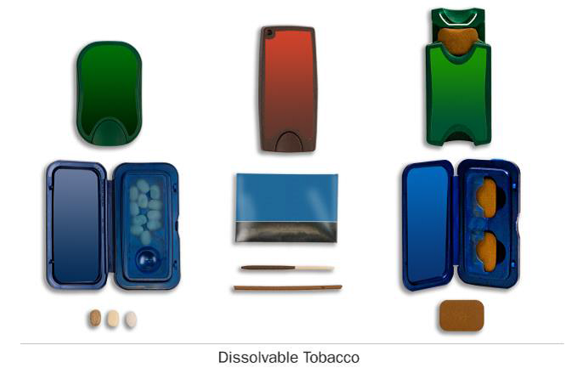
51. Have you ever seen or heard of dissolvable tobacco before this study?
1 [ ] Yes
2 [ ] No [END QUESTIONS]
-8 [ ] DON’T KNOW [END QUESTIONS]
-7 [ ] REFUSED [END QUESTIONS]
ASK: All respondents
[SHOW GENERIC IMAGES OF DISSOLVABLES]
52. Have you ever used dissolvable tobacco products, such as Ariva®, Stonewall™, or Camel Orbs, Sticks, or Strips, even one or two times?
1 [ ] Yes
2 [ ] No [END QUESTIONS]
-8 [ ] DON’T KNOW [END QUESTIONS]
-7 [ ] REFUSED [END QUESTIONS]
ASK: Respondents who have seen or heard of dissolvable tobacco (Q51 = 1).
[SHOW GENERIC IMAGES OF DISSOLVABLES]
53. Do you now use dissolvable tobacco…
1 [ ] Every day
2 [ ] Some days
3 [ ] Not at all [GO TO Q54]
-8 [ ] DON’T KNOW [GO TO Q54]
-7 [ ] REFUSED [GO TO Q54]
ASK: Respondents who have used dissolvable tobacco (Q52 = 1).
54. In the past 30 days, have you used dissolvable tobacco, even one or two times?
1 [ ] Yes
2 [ ] No
-8 [ ] DON’T KNOW
-7 [ ] REFUSED
ASK: Respondents who have used dissolvable tobacco AND do not currently use dissolvable tobacco every day or some days (Q53 = 3, DK, RF).
55. When did you last use dissolvable tobacco?
1 [ ] In the past hour
2 [ ] Sometime today
3 [ ] Yesterday
4 [ ] Day before yesterday
5 [ ] Three or more days ago
-8 [ ] DON’T KNOW
-7 [ ] REFUSED
ASK: Respondents who use dissolvable tobacco every day or some days (Q53 = 1, 2, -8, or -7).
56. How many pieces of dissolvable tobacco have you used in your entire life?
1 [ ] 1 to 10
2 [ ] 11 to 20
3 [ ] 21 to 50
4 [ ] 51 to 99
5 [ ] 100 or more
-8 [ ] DON’T KNOW
-7 [ ] REFUSED
ASK: Respondents who have used dissolvable tobacco (Q52 = 1).
57. About how long has it been since you last used dissolvable tobacco? (If it was earlier today, enter 1 day)
1 [ ] I___I___I DAYS
2 [ ] I___I___I MONTHS
3 [ ] I___I___I YEARS
-8 [ ] DON’T KNOW
-7 [ ] REFUSED
ASK: Respondents who have used dissolvable tobacco (Q52 = 1) and do not use every day
(Q53 <> 1).
PROGRAM: EXCLUDE Some day users (Q53 = 2) who previously reported they last used in the past hour, sometime today, yesterday, or the day before yesterday (Q55 = 1 or 2 or 3 or 4).
GO TO: If Q53 = 3, go to Q58. Else, End Questionnaire.
58. Have you completely quit using dissolvable tobacco?
1 [ ] Yes
2 [ ] No
-8 [ ] DON’T KNOW
-7 [ ] REFUSED
ASK: Respondents who have use dissolvable tobacco (Q52 = 1) and currently use not at all (Q53 = 3)
Protocol source: https://www.phenxtoolkit.org/protocols/view/741401

