
Data Collection Worksheet
Please Note: The Data Collection Worksheet (DCW) is a tool to aid integration of a PhenX protocol into a study. The PhenX DCW is not designed to be a data collection instrument. Investigators will need to decide the best way to collect data for the PhenX protocol in their study. Variables captured in the DCW, along with variable names and unique PhenX variable identifiers, are included in the PhenX Data Dictionary (DD) files. The following protocol is part of a national examination study.
Note: Detailed videos illustrating this procedure can be found on the National Health and Nutrition Examination Survey (NHANES) website.
Protocol to Determine the Midpoint
The mid-upper arm circumference is measured on the right arm at the level of the upper arm midpoint mark. The examiner makes this mark on the posterior surface of the arm immediately after measuring the upper arm length. The procedures for making the mid-arm circumference mark are explained below:
1. Position the participant: Direct the participant to turn away from you. Ask participant to stand upright with his/her weight evenly distributed on both feet, the right arm bent 90 degrees at the elbow, and the right palm facing up. Demonstrate the correct position if necessary. Remove any covering from the participant’s arm.
For infants and children unable to stand, instruct the parent (or guardian) to sit with the child in his or her lap. Ask the parent to remove any clothes from the child’s arm.
Have the participant bend the arm or have the parent bend the child’s arm at the elbow to a 90-degree angle.
2. Mark the measurement site: Locate the lateral end of the spine of the right scapula by following the scapula out to the arm until it makes a sharp V-turn to the front of the body. Using the cosmetic pencil, make a horizontal line on the uppermost edge of the posterior border of the spine extending from the acromion process (see Exhibit 1).
3. Take the measurement: Hold the zero end of the measuring tape at this mark and extend the tape down the posterior surface of the arm to the tip of the olecranon process, the bony protrusion of the elbow (Exhibit 5). Take the measurement to the nearest 0.1 cm. IMPORTANT: The tape must be centered on the posterior surface of the arm. Exhibit 2 shows the correct placement of the measuring tape centered on the posterior surface of the arm; whereas Exhibit 3 shows the measuring tape placed incorrectly.
4. Divide the measure in half to calculate the midpoint of the measured length. Make a horizontal mark at the midpoint and cross this mark with a perpendicular line (Exhibit 4). IMPORTANT: The vertical line must be centered on the posterior surface of the arm. This mark defines the site at which the arm circumference will be measured.
5. Finally, tell the participant to relax the right arm. Proceed to the arm circumference measurement.
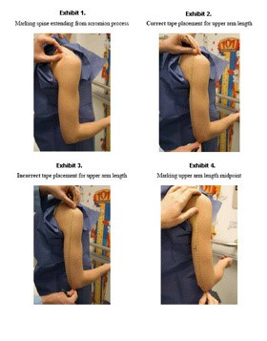
Exhibits 1-4.
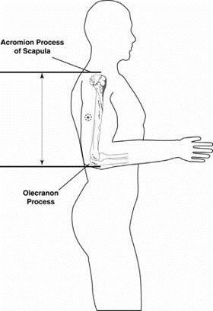
Mid-Upper Arm Circumference Measurement Protocol
1. Position the participant: Ask the study participant to turn so that you stand facing his or her right side. Have the participant stand upright with the weight evenly distributed on both feet, the shoulders relaxed, and the right arm hanging loosely at the sides. Flexing or tightening the arm muscles will yield an inaccurate measurement.
2. Take the measurement: Continue to stand facing the right side of the study participant. Wrap the measuring tape around the arm at the level of the upper arm midpoint mark. Position the tape perpendicular to the long axis of the upper arm and make sure the tape is level around the circumference. Pull the two ends of the overlapping tape together so that the zero end sits below the measurement value and the result lies on the lateral aspect of the arm (not the posterior surface). Check that the tape fits snug around the arm but does not compress the skin. Take the measurement to the nearest 0.1 cm.
Protocol source: https://www.phenxtoolkit.org/protocols/view/21101

